# **ASSIGNMENT 2**

**NAME: Laiyancemary A**

**Reg.No: 812019106016**

**Build a python code, Assume u get temperature and humidity values (generated with random function to a variable) and write a condition to continuously detect alarm in case of high temperature.**

**Code:**

import random  
while(True):  
 temp=random.randint(10,99)  
 humid=random.randint(10,99)  
 print("current Temperature:",temp)  
 print("current Humidity:",humid,"%")  
 temp_ref=37  
 humid_ref=35  
 if temp>temp_ref and humid<humid_ref:  
 print("Sound Alarm")  
 else:  
 print("Sound Off")  
 break

**Result:**

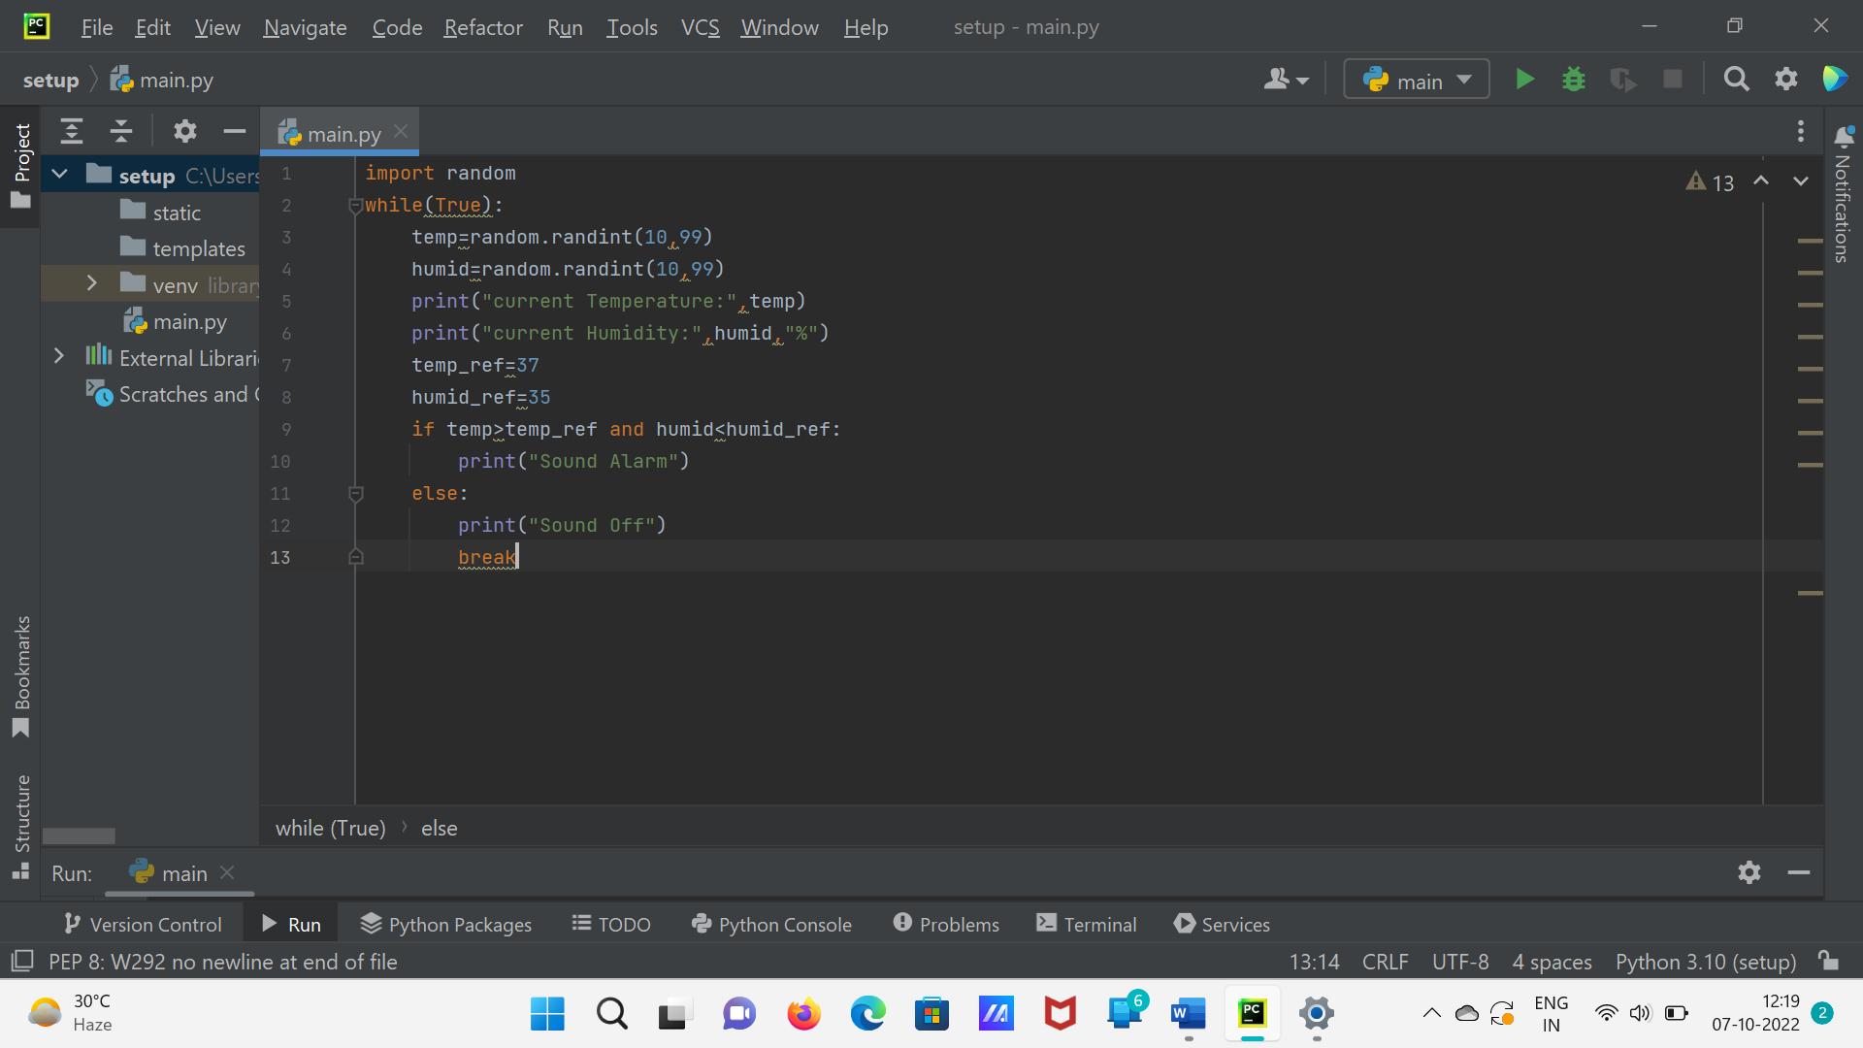

**Output:**

